IMPLEMENTATION OF LOTE LANGUAGE AT
KOROROIT CREEK PRIMARY SCHOOL

REPORT TO THE SCHOOL COMMUNITY
SEPTEMBER 2014

Nicole Oakley Natalie Bakai
School Council President Principal
Executive Officer School Council

Index

Introduction
Rationale
Associated benefits of learning an additional language 3

LOTE Strategy Plan 5

Outcomes of Strategy Plan
Current Language Groups at Kororoit Creek Primary School 6

Languages Spoken at Local Primary Schools and Colleges June 2014 7

City of Melton Profile 7

Parent Survey 8

Student Survey 9

Staff Survey 11

Current Students Attending Language Programs 11

Reflection on Research and Surveys 13

Recommendations 13

Frequently Asked Questions 14

Bibliography 16

Introduction
Kororoit Creek Primary School Council has been instrumental in the development of a strategy plan, formation of a working party and review of its recommendations relating to the implementation of a LOTE (Languages Other Than English) program for all Prep students from 2015. This process has been undertaken in consultation with members of our community including students, parents and staff and has informed work party recommendations and the decision of the School Council. The rationale and outcome of the School Council decision, is contained within this document and presented to the Kororoit Creek Primary School Community.
The School Council would like to that all members of its community, including students, staff and parents, for their considered responses and feedback in relation to the LOTE consultation process which have been invaluable in informing their decision.
Rationale
The vision of the Victorian Government for all Victorian government schools in relation to LOTE implementation centers on an ambitious goal that by 2025 all students from Prep (Foundation) to Year 10, will study a language in addition to English by 2025, starting with Prep in 2015.
This goal is supported by research focusing both on language acquisition and the additional benefits that language learners acquire in the process of learning another language. (Languages Expanding Your World. DEECD Melbourne June 2013. State of Victoria).
The International Baccalaureate (IBO) is committed to supporting multilingualism as fundamental to increasing intercultural understanding and international-mindedness, as well as supporting the numerous benefits that learning another language brings. As a Primary Years Programme (PYP) candidate school we are also committed to this standard as it directly supports our students in their quest as PYP inquirers and in their development as internationally minded citizens.

Associated benefits of learning an additional language
(All related research is cited at the end of this document).

Learning an additional language give learners a unique international perspective by opening their minds to other cultures and opening doors to new possibilities. Languages take learners on a journey that improves the way they communicate, interact with others and engage with learning, and with life, at home and beyond regardless of the language that is studied.

The acquisition of any additional language and associated intercultural skills supports how children and young people at preschool and at school develop, both intellectually and emotionally. Learning languages fosters creative thinking, enhances critical thinking, and encourages divergent and imaginative thinking.
In learning a language, students broaden their thinking as they learn to interact with people from diverse backgrounds and as they explore and reflect critically. Seeing things from different perspectives helps them to become divergent thinkers. By learning to notice, connect, compare and analyze aspects of language students develop critical thinking skills as well as analytic and problem-solving skills.

In 2011, the Victorian Government set out to revitalize the way languages are valued and taught in Victoria’s schools and educational settings. Its Vision for Languages Education articulates why languages are vital, and why they need to be part of every young person’s education journey. The benefits of languages education to learners, the community and the Victorian economy were summarized as follows:
Languages education offers significant benefits for Victorian students, their families and communities. At school, it helps our children and young people to develop their first language literacy, problem-solving, intercultural and communication skills, and it equips them for a wide range of experiences.
Australian and international research demonstrates the benefits in developing literacy in more than one language.
Authoritative work by Cummins and Swain looking into bilingual education describes a model of common underlying proficiency across languages, where the literacy-related aspects of a bilingual’s proficiency in first and second languages are seen as common or interdependent (1989:82).
Similarly, Australian Literacies (Lo Bianco, 1997:55) identifies recent Australian research demonstrating that monolingual English speakers learning a second language gain in their early literacy through improved word attack and word recognition skills. It is apparent that ‘far from impeding the acquisition of literacy in English... engagement with a second or additional language may provide learners with concrete cognitive and metalinguistic benefits’ [ability to understand and discuss how language operates]. This is confirmed by:
• Clyne et al. (1995:8), who showed that exposure to as little as one hour per week of a second language in the earliest years of primary school advances the age of reading readiness in English; and
• Yelland et al. (1993:423), whose Australian study showed that after as little as six months of language classes for one hour per week, the children had a ‘significantly higher level of word awareness than their monolingual counterparts’.
Bialystok, in Yelland et al. (1993:428), concludes that ‘increases in a child’s competency in the second language contribute to the extent of the child’s access to explicit knowledge of language structure’ and that this is ‘critical to the development of metalinguistic awareness’.

Metalinguistic awareness was also among the potential advantages of bilingualism identified by Makin et al. (1995:38), along with increased problem- solving abilities, cognitive flexibility and verbal creativity.
As well as enhancing the development of specific literacy skills, learning another language provides access to the expression of underlying literacy or literacies, and allows students to more easily decode language, make comparisons between languages, and draw conclusions about how language works.
This research overwhelmingly supports the acquisition of another language as a positive rather than a negative influence on language development in both the primary and additional language.
LOTE Strategy Plan
In seeking to address the needs of our community including students, parents and staff the School Council developed a LOTE Strategy Plan to ensure a focused, cohesive process was developed for the implementation of the program at Kororoit Creek Primary School. Major areas addressed within the plan included:
- Establishment of a School Council Working Party
- On-going research to inform decision making
- Collection of data on languages currently spoken by families within the school community
- Consultation with parents, student representatives and staff seeking feedback on issues to be considered when considering LOTE for 2015
- Data collection from City of Melton on languages other than English spoken by residents
- Collect information on provision of LOTE at local secondary schools/colleges
- Reporting to the school community through the school newsletter.

These areas will be considered in conjunction with curriculum implementation which is managed by the school principal and reported to the School Council and includes
- Investigating modes of delivery of LOTE program including CLIL (Content and Language Integrated Learning) model.
- Visit to primary schools implementing alternative modes of curriculum delivery
- Establishment of Sister School relationship offering LOTE language both within Australia and overseas in target language
- Establishment of feasibility study on visit / exchange programs to sister school/s including risk assessment, target area and cost
- Employment of high quality, appropriately trained and qualified teacher for LOTE
- Development of program for all Prep children commencing in 2015
- Feasibility study of offering a single Unit of Inquiry incorporating LOTE across all year levels to expose students throughout the school to the benefits of additional language learning.

Outcomes
This section of the report details outcomes of actions currently available related to the LOTE Strategy Plan.

Current Language Groups at Kororoit Creek Primary School and Kindergarten.
Language data across Kororoit Creek Primary School P-6 as at June 2014 identifies the following:
- Almost 75% or 500 of our children across the school speak English as their main language at home.
- Other than English, there is no one predominant language group.
- At Kororoit Creek Primary School five hundred or 74% of students speak English as their main language at home.
- There are no individual language groups with 5% or more children that speak a language other than English at home.
- Whilst both Hindi and Macedonian represent the main language categories spoken at home they only representative 4% each, or less, of 760 children at the school.
- Of the remaining students there are another ten language groups that represent between 1 and 3% of students.
- Where less than ten students speak a particular language they are not individually counted. Forty additional language groups fall into this category (less than 10 children in any group)
- The total number of languages spoken at homes of children in the school is fifty one.

Language data across Kororoit Creek Kindergarten – 4 year old as June 2014 identifies the following:

Kindergarten data correlates closely to school data with the clear majority of children speaking English at home as their preferred language.
- At Kororoit Creek Kindergarten one hundred and forty six or 85% of students speak English as their main language at home.
- Whilst Urdu and Hindi represent the main language categories spoken at home they only representative 5% each, or less, with 9 and 6 students in each category.
- Of the remaining students there are another four language groups that represent between 1 and 3% of students.
- Where less than ten students speak a particular language they are not individually counted.

Languages Spoken at Local Primary Schools and Secondary Colleges as at June 2014
There are a variety of languages spoken across both Primary and Post-Primary facilities in the area:
Brookside – Indonesian
Creekside Year 7 & 8 – Indonesian
Lakeview Years 10-12 – None
Parkwood Green – None
Taylors Hill – None
Overnewton – German, Indonesian and Japanese
Bacchus Marsh- Grammar, French and Japanese
Copperfield College – Japanese and Italian
Vic Uni Secondary College – Vietnamese
Taylors Lakes Secondary – Italian and Japanese
Christ the Priest – Italian
Southern Cross Grammar – Mandarin
St George Preka – Italian

Secondary Schools and Colleges were contacted regarding the placement of primary students in secondary LOTE classes when transitioning from Year 6 to 7. Schools who responded uses two main strategies. (i) Students are placed in classes depending on their prior knowledge of a particular LOTE language and (ii) There is no placement according to prior knowledge. All students are allocated to LOTE classes randomly with some students being new to the LOTE and others having previously learned the particular language to be taught.

Schools that responded also stated that students with no prior knowledge of LOTE quickly caught up with students that had previous experience in particular languages and were not disadvantaged.

City of Melton Community Profile
The latest City of Melton Community Profile is available on http://profile.id.com.au/melton/language and is summarised below. Please note although this data Is dated 2011 this is the most current information available.

Dominant groups
Analysis of the language spoken at home by the population of the City of Melton in 2011 compared to Greater Melbourne shows that there was a smaller proportion of people who spoke English only, and a similar proportion of those speaking a non-English language (either exclusively, or in addition to English).
Overall, 65.8% of the population spoke English only, and 28.9% spoke a non-English language, compared with 66.3% and 29.1% respectively for Greater Melbourne.
The dominant language spoken at home, other than English, in the City of Melton was Filipino/Tagalog, with 2.4% of the population, or 2,609 people speaking this language at home.
The major differences between the languages spoken at home for the population of the City of Melton and Greater Melbourne in 2011 were:
- A larger percentage speaking Maltese at home (2.1% compared to 0.4%)
- A larger percentage speaking Filipino/Tagalog at home (2.4% compared to 0.7%)
- A smaller percentage speaking Mandarin at home (0.7% compared to 2.5%)
- A smaller percentage speaking Greek at home (1.4% compared to 2.8%)

Emerging groups
Between 2006 and 2011, the number of people who spoke a language other than English at home increased by 12,413 or 64.7%, and the number of people who spoke English only increased by 16,486 or 29.8%.
The largest changes in the spoken languages of the population in the City of Melton between 2006 and 2011 were for those speaking:
- Vietnamese (+1,092 persons)
- Filipino/Tagalog (+1,074 persons)
- Arabic (+830 persons)
- Punjabi (+675 persons)

Parent Survey
On June 20, 2014 parents were surveyed to seek their input into the establishment of a LOTE program to be phased in to Prep in 2015 in accordance with The Victorian Government’s Vision for Languages Education in Victorian Government Schools. The survey provided some general information including languages spoken at home by our students in both the school and the kindergarten, major language groups within the community and languages currently provided by local schools or colleges.

Fifty-nine families returned surveys to the school with many providing information they felt should be considered in informing the process of language selection for our students. Comments included selecting a language that:
- Is widely used
- Is not already spoken by students
- Might be transferred to secondary education
- Is interesting
- Is used in business / working life
- An international language not a home langue
- Is commonly taught
- Is not taught in any other school
- Is good for fine motor skills
- Can be used when travelling to that country in the future
- A useful language
- Is easy to write / learn and speak
- Uses the English alphabet
- Can be taught at home – Rosetta Stone
- Is easy to write – our alphabet
- Is spoken widely
- Skills can be developed in time available eg European language
- Language that is used in a variety of countries
- One that can further develop the student’s understanding of English.
- Fun
- Enables you to link to more than one language
- Uses words that link to other languages
- Not one that the children currently speak
- Promotes understanding of the culture and society linked to the language
- Different from own culture

Of the parents that responded to the survey, all but one nominated a preferred language or languages. In order of preferences the majority of parents listed
- French
- Japanese or
- Mandarin as their first preference.
The following languages were also nominated but received, at the very most, less than two-thirds of the preferences of those above, with several of the languages at the lower end nominated by only one or two families.
- Italian
- Indonesian
- Spanish
- German
- Macedonian
- Hindi
- Serbian
- Tamil
- Arabic
- Vietnamese
- African
- Greek and
- Urdu

Student Survey
Two class captains were selected from each year level together with School and Sports Captains in Year 6 to form a focus group on LOTE provision within the school.
The focus group worked with a senior member of staff to answer the question:
“What would an outstanding LOTE program Look Like, Sound Like and Feel Like?”
This question was designed to inform program development and student engagement and to ensure students had input into curriculum design. A Venn diagram thinking tool was used to support students who worked in multi-age groups supported by a senior school leader and facilitated by a member of the principal class.
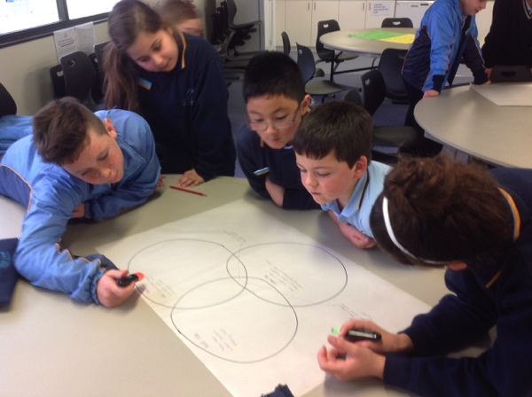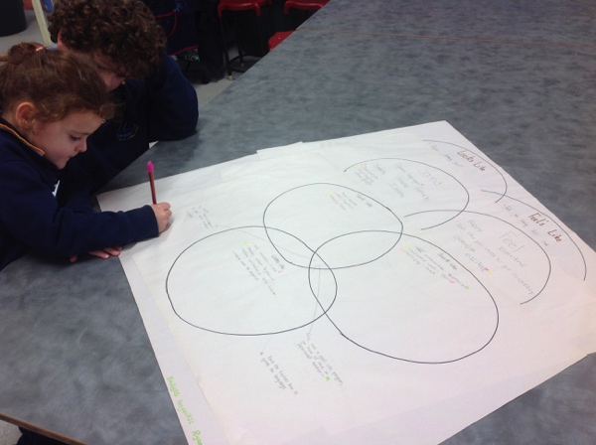
Students were highly engaged in the process and worked collaboratively to articulate their thoughts and feels about a potential LOTE program within the school. In the final stages of the process, students were given the opportunity to share their ideas and to mark those they thought were the most important with a highlighter. The following statements represent student thoughts on what an outstanding LOTE program would Look Like, Sound Like and Feel Like:

Looks Like | Sounds Like | Feels Like
People working together in groups | Having fun in the LOTE program | Having a great time
Posters | Understanding | Being part of a group
People having fun | Talking | Trying your best
Hard characters - Chinese | Hard pronunciation - Yugoslavian | Warm - French
Confusing letters - Yugoslavian | Complicated words - Italian | Hard - Yugoslavian
Confusing combination of letters - Indian | Challenging - Greek | Confusing - Italian
Cultural activities | Different languages. French, Spanish, Chinese, Italian | Happy
Games, photos, role plays, singing, dancing | People encouraging other people | You want to go to that Country
Cultural activities |  | Grateful
Lots of different people committing to the same language | An international Language | Exciting to learn a new langague
Wanting to be a part of LOTE | You would hear lots of interesting facts | Like you are not being left out
Seeing international objects | Like lots of different people speaking the same language
Children doing drawings about the language

Interesting comments made by students included:
- To have a good LOTE program you have to have an experienced teacher
- You would be more intelligent if you knew another language
- It would look like and sound like people being big risk-takers
- People don’t want to give up when they hear other people doing (saying) the right thing
- Someone to teach the teachers how to speak the language.

.
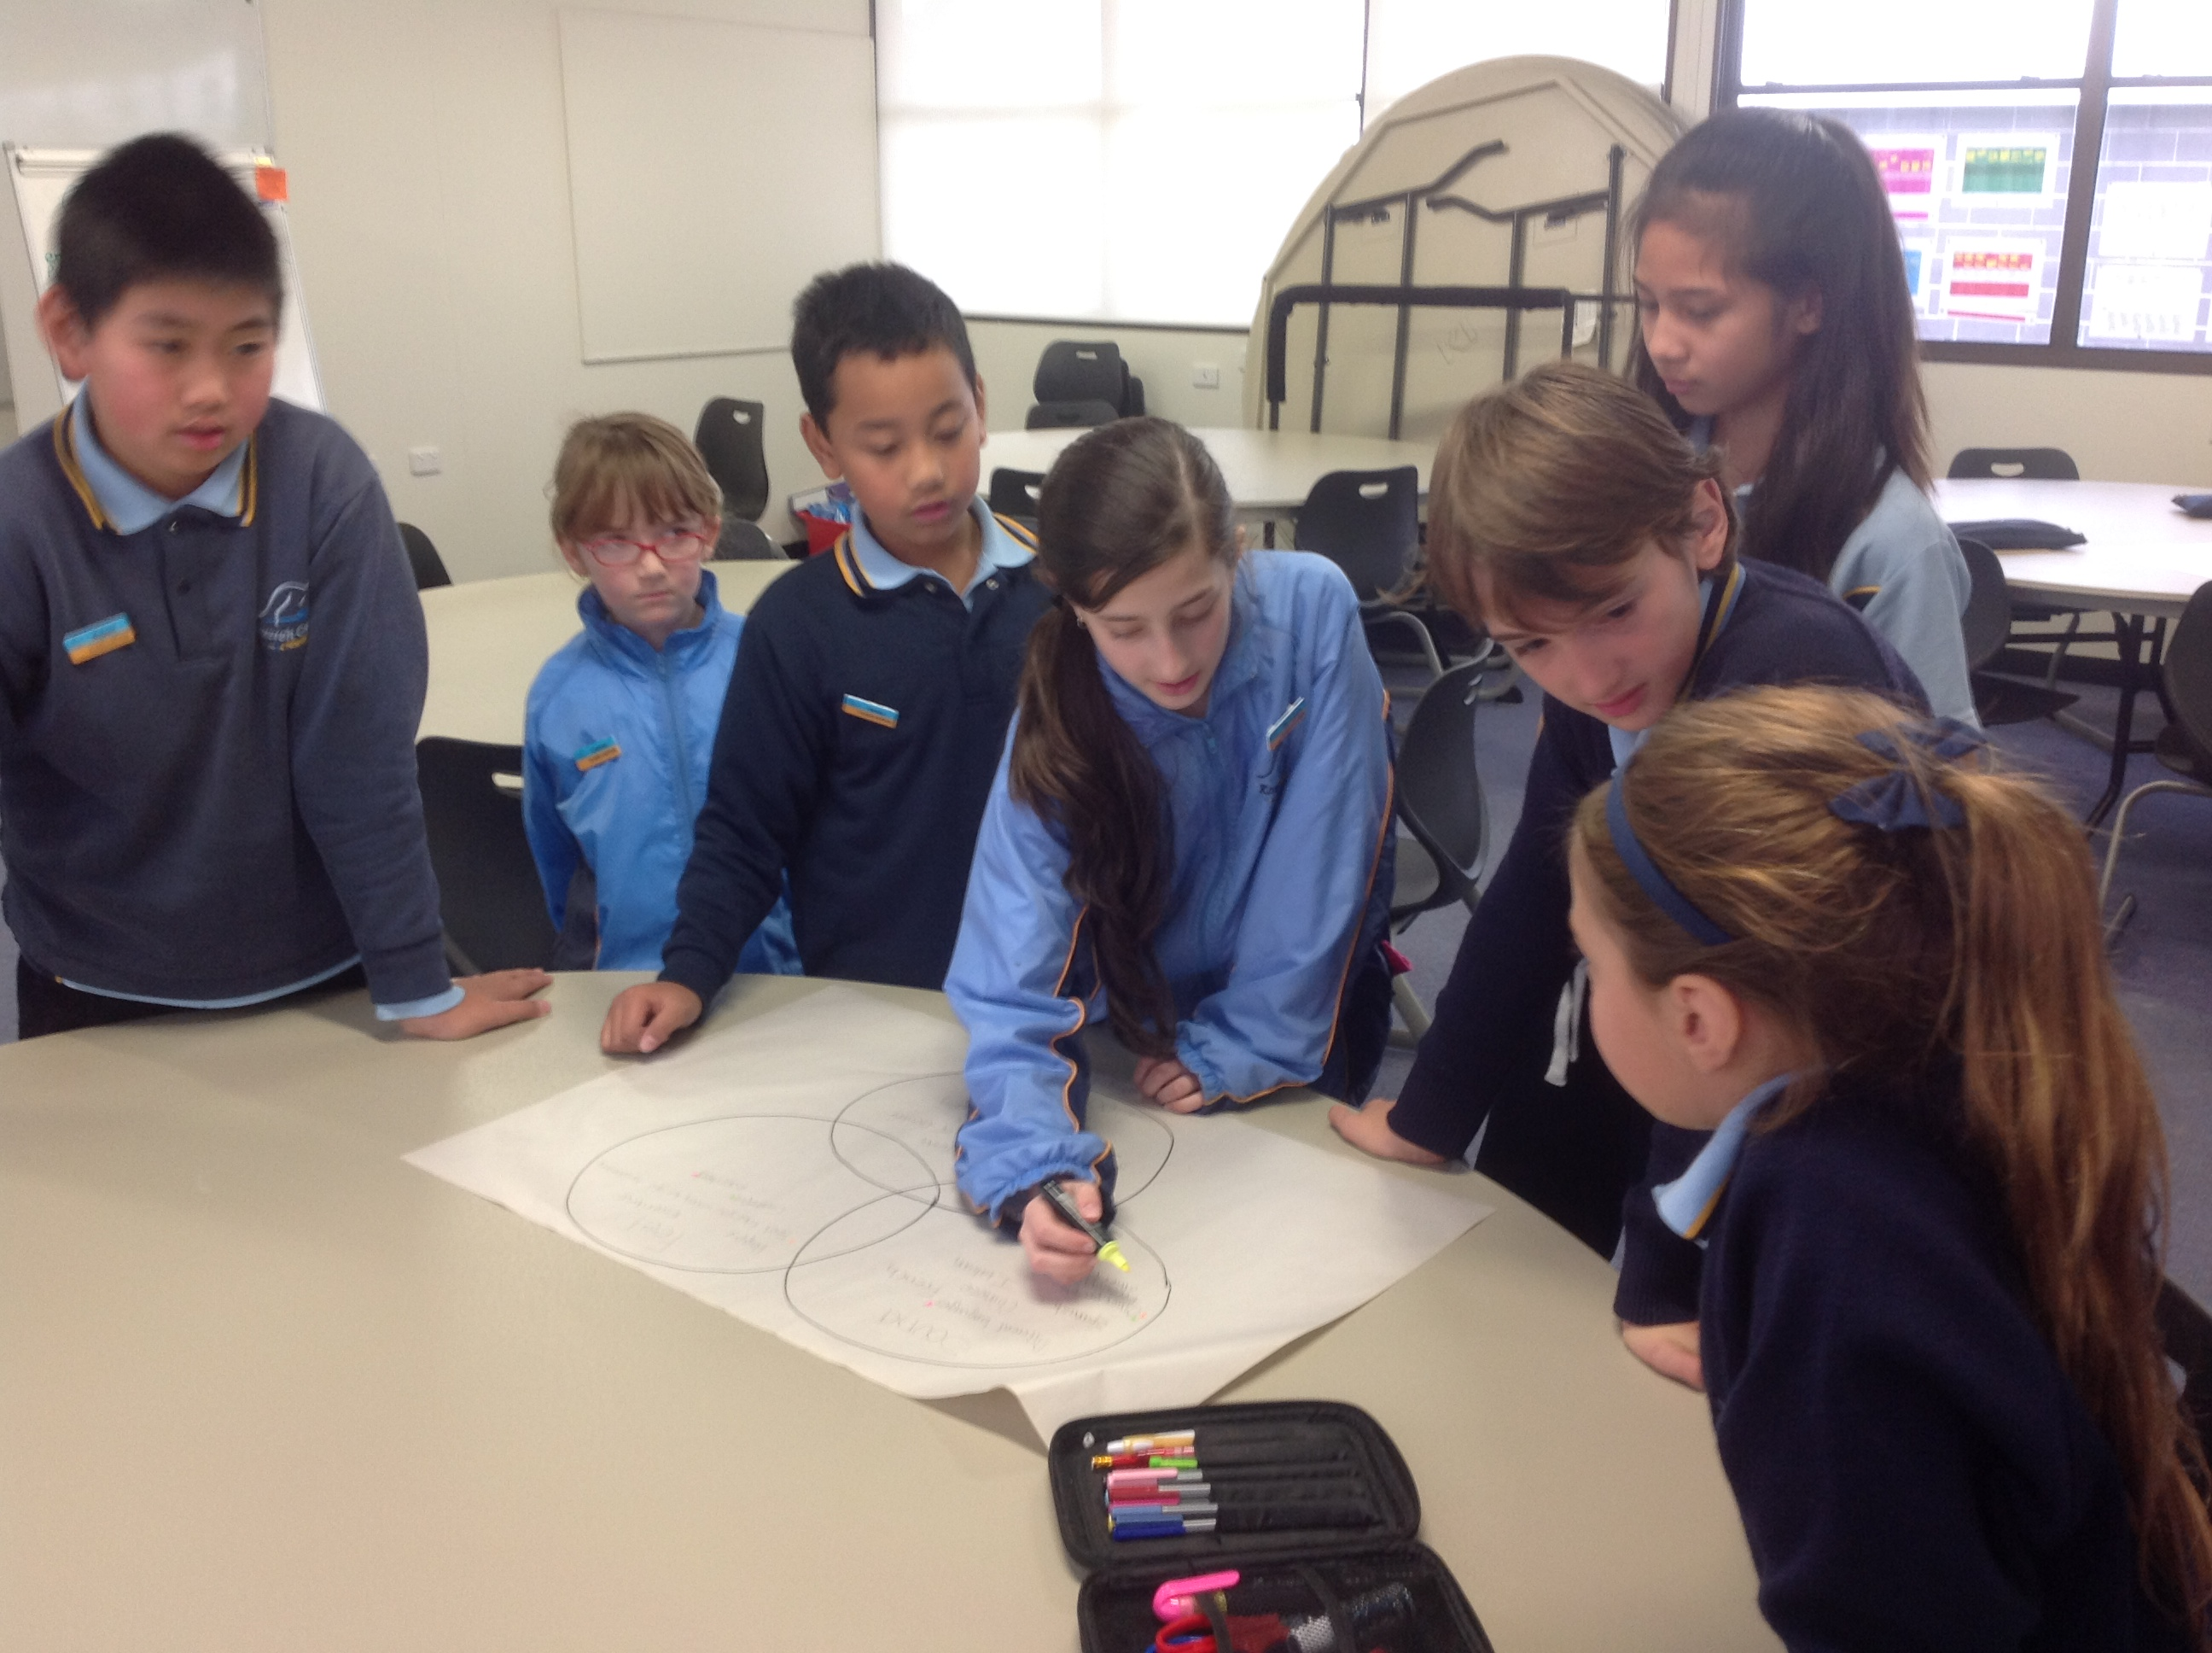

With thanks to Ally, Cassandra, Escher, Sonix, Alexa, Robert, Lauren, Aleksa, Ethan, Isabella, Michaella, Emily, Keegan, Ryan, Maddison and Ryan

Staff Survey
All staff, across both the kindergarten and school, were surveyed to seek their input into the question.
“What are the key considerations for the implementation of a high quality, engaging LOTE program?”
This question was designed to inform the human, physical and financial resourcing of the program both in the long and short term.

Responses received were consistent and focused on the following aspects for consideration:
- Highly engaging and enthusiastic teacher with prior knowledge of PYP is critical for the success of the program
- Providing authentic opportunities to use the language
- Integration of the language within the school through both planned and incidental opportunities
- Integration into specialist areas through the Content and Language Integrated Learning (CLIL) process
- Articles in the newsletter and website areas in chosen language
- Engaging LOTE blog
- Provision of student consultation
- Inclusion of celebration/s
- Integration of ICT
- Explicit links between the LOTE program and Units of Inquiry
- Teaching of key vocabulary
- Resourcing of program
- Combined planning time with LOTE teacher
- Making connections with other schools using CLIL / teaching same LOTE
- Establishing Sister-School relationship
- Development of oral language within the context of authentic learning
- Development of an understanding of cultural norms/traditions/history etc
- Developing LOTE continuum
- Language highly spoken throughout the world
- Language that offer ‘transferability’ between other languages
- Strong focus on oral language development
- Use of wide range of resources / strategies

Current Students attending Language Programs
Victoria has a number of strengths which position us to emerge as a global leader in languages education.
We are one of the world’s great multicultural societies. We speak more than 200 languages and over 40 per cent of us have at least one parent born overseas. We already have the highest participation rate in languages education in Australia and teach a diverse range of languages in our government and non-government schools and other education and training providers.
Our complementary providers, the Victorian School of Languages and community languages schools, provide distance education and out-of-hours classes in more than 50 languages to over 52,000 students, many of whom are studying their first language and exhibit great potential to be mentors and advocates for languages in their home schools.
A number of our current students attend either Saturday or Sunday classes of the Victorian School of Languages (VSL) or Community Language Schools which provide instruction in a number of languages other than English. Several opportunities are available for students wishing to pursue their own Mother Tongue or home language in surrounding areas including Taylors Lakes, Brimbank, Keilor, Sunshine, Altona and Footscray.

We currently have 22 students attending classes through the Victorian School of Languages including Spanish, Arabic, Macedonian, Chinese, Maltese, Punjabi and Hindi.

Reflection on the Research and Surveys

Reflecting on the research, confirming information and reviewing it in terms of aligning broad community needs including students, parents and staff, the following information informed the discussion and subsequent recommendation of the LOTE language.

- Research clearly indicates there are many associated benefits of learning any additional language
- There are over fifty different languages groups within the school
- The kindergarten data aligns closely with school data.
- Apart from English, there is no dominant language group within the school
- 22 of 760 students attend community language schools.
- Students who attend community language schools attend 7 different schools
- Two of the schools previously surveyed will be offering an additional or new language as part of their LOTE program.
- Both Brookside P-9 and Creekside P-9 will be offering French as a LOTE language
- Bearing this in mind, the likelihood is that Lakeview Senior College will also offer French as an option as students studying LOTE reach the Senior College
- All bar one of the parents surveyed nominated a language of preference. In order of preference the majority of parents listed; French, Japanese and Mandarin
- As can be seen by the students surveyed the focus of their input was more on their expectations of what a program might look like, sound like and feel like. Of languages that were mentioned French and Chinese featured.
- The staff survey focused more on the need to have a qualified LOTE teacher with a knowledge of the Primary Years Programme and the opportunity to use the language in authentic situations

In considering the LOTE language of choice the Department of Education and Early Childhood Development also stress the need to consider.
- Provision of qualified staff
- Community Languages
- Languages offered by neighborhood schools

In terms of the provision of a qualified language teacher, Kororoit Creek Primary School is extremely fortunate in having an on-going member of staff who is a native of France and qualified there as a primary school teacher. This teacher has an equivalence certificate to teach in Australia and has also been accredited by DEECD as a fully qualified LOTE teacher.

Recommendations
Taking all aspects of the consultation into consideration it the School Council’s opinion that the Language Other Than English (LOTE) that would be best suited to Kororoit Creek Primary School students, staff and broader community is French. It is further recommended that, in accordance with Government requirements, French is adopted as the LOTE language to be taught from Prep in 2015.

The School Council would like to thank the students, staff and parents who contributed to the consultation and ensured broad considerations as well as specific areas of need were taken into account.

Frequently Asked Questions
Achieving literacy is difficult so isn’t it better to focus on English rather than on other languages? Learning another language can enhance literacy in English. Through the study of another language students have the opportunity to compare how the two languages work and so gain a better understanding of English as a language system.
What is CLIL? Content and Language Integrated Learning (CLIL) is an approach to languages education that immerses students in the target language by using it to teach other subjects, such as art or music. Both the language and the subject content are taught at the same time.
CLIL has been widely used in Europe since the 1990s and schools and languages teachers are now using this model in Victoria.
English is the only learning area where literacy can really be addressed. Literacy is developed in all areas of the curriculum. As such, all teachers are responsible for supporting the literacy development of their students. However, because literacy is about language, the study of another language can enhance literacy, language and communication skills.
How can learning a second language help English literacy? There is a lot of evidence to suggest that learning an additional language can enhance English literacy in ways such as:
- comparing features of their first language with those of another language learners are better able to understand the structure and workings of English
- language learners develop and enhance their skills and strategies for decoding and making meaning from words and this transfers to English.
- Learners develop flexibility and competence in dealing with language concepts.
- An additional language can provide a new beginning and success for learners who have struggled with English. This has been shown to be beneficial, both in terms of English language development and for the self-esteem of learners.
- Languages are only for academically able students so less able students shouldn’t have to do them. It is quite normal for people to speak more than one language. The assumption that only academically able students should learn another language is based on a tradition of associating language study with the classics. This historical practice has nothing to do with the ability of people to acquire language because we know that this ability is not linked to particular intelligence.
If English is already a second language should a child study a third? Most people in the world speak more than one language. None of the studies of multilingual acquisition demonstrates negative effects from learning more than two languages. In fact, it seems the more languages you learn the more able you are to learn language. Added to this are the advantages of being able to experience the cultures and ideas of different people through their language.
For English as an Additional Language students, learning a third language can be a positive experience because their skills in that language are comparable to the skills of their classmates. It also provides these students with further opportunities to consider English as a language system. Will studying another language be confusing for children?
Successful language learners transfer their knowledge about language from one language to another. By using cross-linguistic strategies, learning and literacy in both languages are enhanced. It is when learners try to keep languages separate, by not recognising the connections that all languages have, there is the possibility for confusion.
What is the point in studying another language when English is now the international language? An important part of being literate in the 21st century is to be able to manage communication and knowledge transfer across languages and cultures. To understand the cultures of other people it is essential to understand how their language works. (ii)*
As LOTE is being introduced to all Prep children in 2015 does that mean that children across the school (Years 1-6) will not have access to LOTE? The School Council recognizes the importance of LOTE learning and of the opportunities that it affords to all children in their education. The current DEECD requirement is that all Prep students study a Language Other Than English (LOTE) in 2015 progressing through schools from Prep-6 and years 7-12 complete by 2021. At Kororoit Creek Primary School, to provide students in years 1-6 with the opportunity to become involved in cultural studies and exposure to LOTE learning, explicit Units of Inquiry will be developed by our Curriculum Director and Team Leaders which will also be supported by the LOTE teacher. Although this will not be a full LOTE program it will provide all students with access to cultural studies and the benefits of LOTE learning through an explicit Unit of Inquiry dedicated to LOTE over a timetabled period during the year.
Bibliography
Clyne, M. et al. (1995) Developing Second Language From Primary School: Models and Outcomes. The National Languages and Literacy Institute of Australia, Canberra
Cummins, J. and Swain, M. (1989) Bilingualism in Education. Longman, New York.
Department of Education, Employment and Training, Victoria (2000) Languages Other Than English (LOTE) On-line Teacher Support Materials materials available Term 2, 2000. This will be released initially as curriculum@work a CD-ROM, and then online on SofWeb.
Department of Education, Training and Youth Affairs (1998) Literacy for All: The Challenge for Australian Schools – Commonwealth Literacy Policies for Australian Schools. DEETYA, Canberra
Department of Education, Victoria (1997) Teaching Readers in the Early Years, Early Years Literacy Program, Addison Wesley Longman, Australia
Department of Education (1998) Teaching Writers in the Classroom , Victorian Early Years Literacy Program, Addison Wesley Longman and Education Victoria, Australia
Department of Education, Victoria (1997) Languages other than English Course Advice, Levels 1–3, Department of Education, Victoria
Emmitt, M. and Pollock, J. (1995) Language and Learning, Oxford University Press, Australia.
Lo Bianco, J. and Freebody, P. (1997) Australian Literacies, Language Australia, Belconnen.
Makin, L., Campbell, J. and Jones Diaz, C. (1995) one childhood many languages, Harper Collins Educational, Australia.
Myers, D. (1992) The Great Literacy Debate, Australian Scholarly Publishing, Kew.
Yelland, G., Pollard, J. and Mercuri, A. (1993) The metalinguistic benefits of limited contact with a second language. Applied Psycholinguistics, Vol. 14, pp. 423–444.

(i)* Languages Expanding Your World
Published by the Department of Education and Early Childhood Development
Melbourne June 2013
© State of Victoria (Department of Education and Early Childhood Development) 2013
(ii)*‘Linking Languages and Literacy: Copyright Commonwealth of Australia reproduced with permission

