A Parent’s Guide to Compass
Compass is a web-based system that is accessible on any modern web browser (Internet Explorer, FIrefox, Chrome, Safari) or by using the Compass iOS or Android apps. Search for 'Compass School Manager' in the store.
This online portal allows you to access up-to-date and meaningful information about our school and your child's progress including:
- Monitor your child's attendance, and enter an explanation for absence or lateness
- Update you family contact information
- View the school calendar
- Download and view your child's Semester Reports
- Book Parent/Student/Teacher Conferences
- Pay and provide consent for events and school fees
Logging in to Compass
Every family receives a separate login to Compass, which will be provided to you by the school. If you are having trouble finding the Compass link for your school you can go to http://schools.compass.edu.au where you can search for and find our school's direct URL or go to the schools website http://kororoitcreekps.vic.edu.au/
To log in you will require your unique family username and password. These details will be provided to you by the school.
Upon first login, you will be required to change your password and confirm your email address and mobile phone number. These details may be used by the school for SMS, password recovery and email communication throughout the year.
If you have lost your details or forgotten your password, you can recover your details by clicking the 'Can't access your account?' link on the front page or contact the school office.
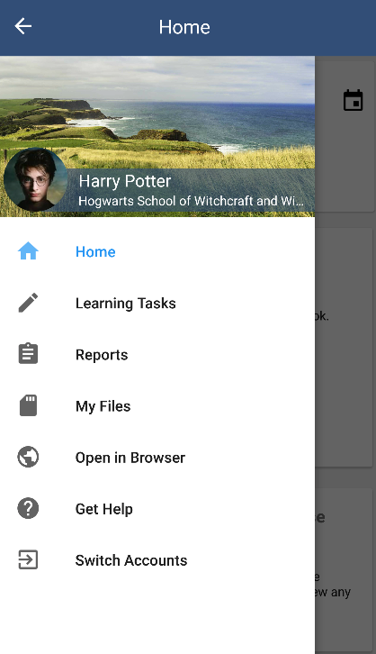
Mobile Access
Apps are available to download for free from the App Store. Once installed and opened for the first time, there will be a prompt to choose which school the user is from. After selecting the desired school there will be an opportunity to enter a Login ID and Password and if successful, the account will be saved to the device.
Please note that the App is limited to newsfeeds and alerts.
To access all other Compass features (e.g. make payments, attendance notes etc), the application needs to be opened in the browser.

Homepage
The home screen provides you with quick access to your child’s profile as well as news and alerts
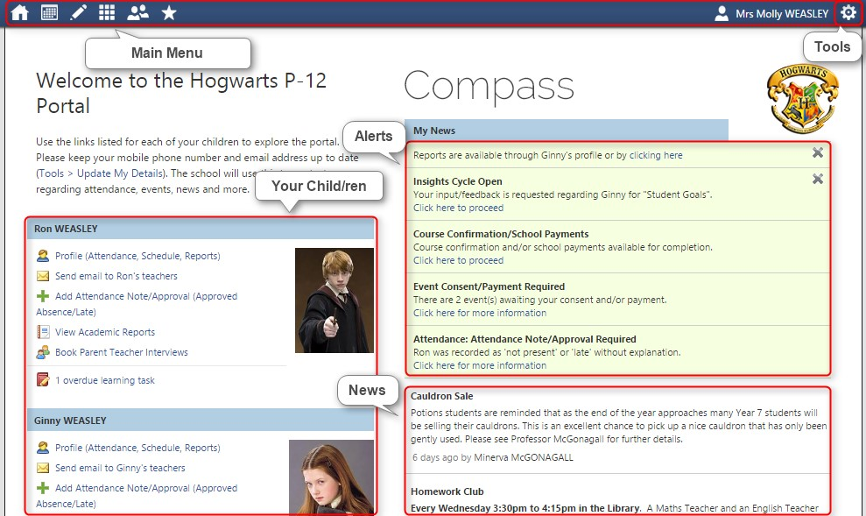
You will receive custom notifications for items that require your action or attention. These may include excursion notifications, ordering options for school photos, absence notifications, surveys, student report availability and more.

Menus and Functions
Along the top of the screen there are various icons, and from these icons you can navigate through the Compass portal.
Events & Course Confirmation/Payments
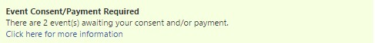
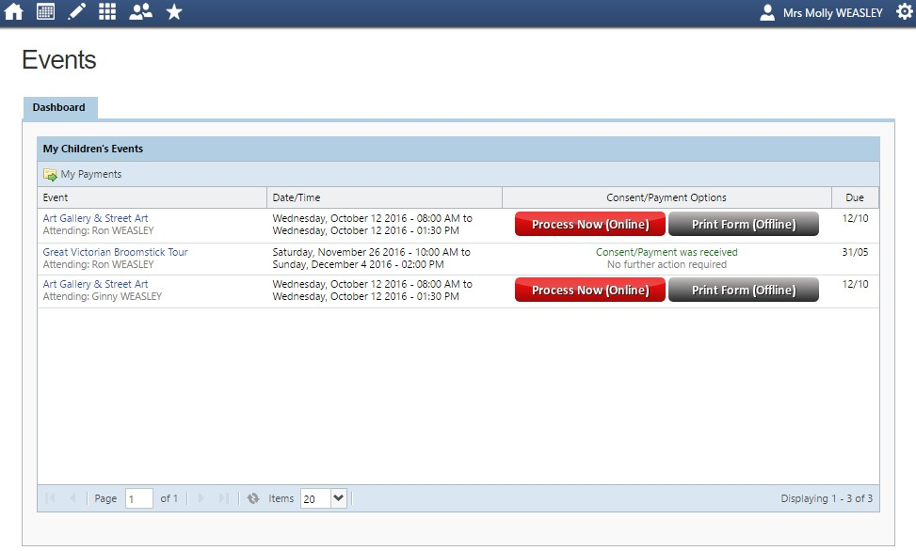
You will receive a notification on your Compass homepage when there is an event or course confirmation that re quires your approval or payment. To provide the consent/payment required, click the notification. This will take you to the Events page or Course Confirmation/Payments page, where you can see all items that require your consent/payment, and those that are upcoming that you have already consented to/paid for

From this page you can pay and consent for any events, or complete the process offline by printing the consent form and handing it in to the school. By clicking the "Process Now (Online)" option, you will be prompted to enter information regarding emergency contact details as well as any updated medical information that is not already on the student's file.

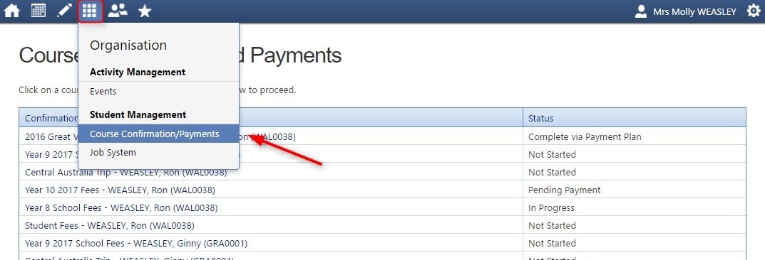

Student Absences

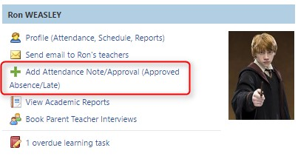
Adding a Note/Approval for a Future Absence

You can enter notes and approvals in advance, if you know that your child is going to be absent from school (e.g. scheduled family holiday.
To do this from your homepage, click on the 'Add Attendance Note/Approval' link listed underneath the name of the relevant student.
This will take you to the Attendance screen, with a pop-up window to enter details of the note or approval. Here you can select the applicable date range - in the future if required.

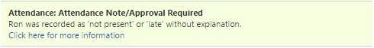
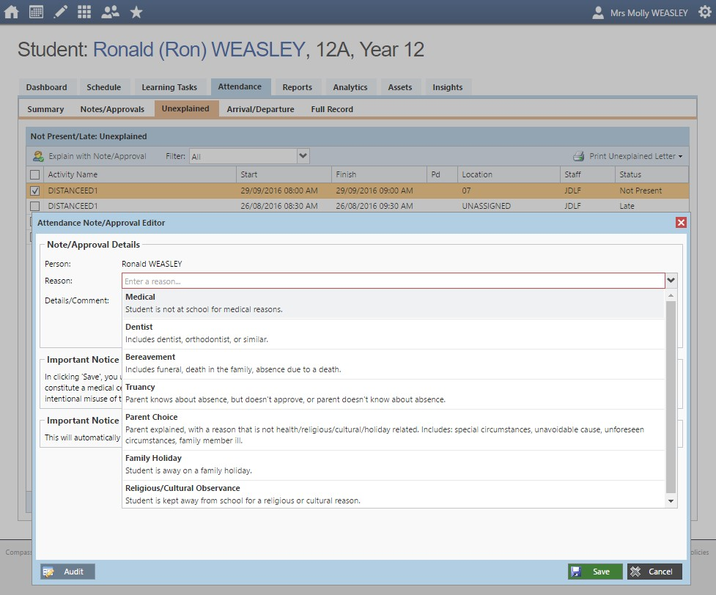
If your child has any unapproved absences or late arrivals, you will receive an alert on your Compass home page letting you know this, and allowing you to add a Note or Approval

Clicking on this notification will take you to the Unexplained tab for that child's attendance, where you can choose to add a Note or Approval for one or more absences. To add a note or approval, select one or more of the absences listed, then select the 'Explain with Note/Approval' button.
Please note that you cannot edit you notes or approvals after they've been created. If you do need to make any amendments please contact your school, as they can do this for you.
Select reason for absence from the drop down box
Assistance
If you require any assistance with accessing Compass, please do not hesitate to contact the school office or drop in.

