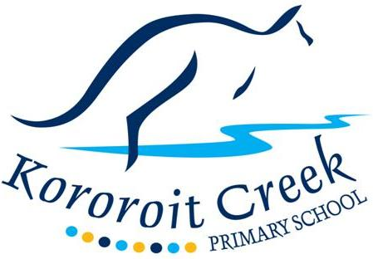
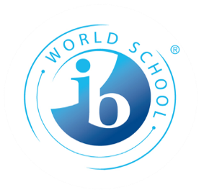

Inclusion and Diversity

Policy

Purpose
The purpose of this policy is explain Kororoit Creek Primary School’s commitment to making sure every member of our school community, regardless of their background or personal attributes, is treated with respect and dignity. Kororoit Creek Primary School strives to provide a safe, inclusive and supportive school environment for all students and members of our school community.

Definitions

Personal attribute: a feature of a person’s background or personal characteristics that is protected by State or Commonwealth anti-discrimination legislation. For example: race, disability, sex, sexual orientation, gender identity, religion etc.
Inclusion and diversity
Kororoit Creek Primary School is committed to creating a school community where all members of our school community are welcomed, accepted and treated equitably and with respect regardless of their backgrounds or personal attributes such as race, language, religious beliefs, gender identity, disability or sexual orientation so that they can participate, achieve and thrive at school.
Kororoit Creek Primary School acknowledges and celebrates the diversity of backgrounds and experiences in our school community and we will not tolerate behaviours, language or practices that label, stereotype or demean others.
Kororoit Creek Primary School will:
- ensure that all students and members of our school community are treated with respect and dignity
- ensure that students are not discriminated against and where necessary, are accommodated to participate in education and all school activities (e.g. schools sports, excursions, concerts, the PYP Exhibition, camps) on the same basis as their peers
- acknowledge and respond to the diverse needs, identities and strengths of all students
- encourage empathy and fairness towards others
- challenge stereotypes that promote prejudicial and biased behaviours and practices
- contribute to positive learning, engagement and wellbeing outcomes for students
- include pro-social values and behaviour to enable students to acquire knowledge and skills, value diversity and build a culture of learning, community and engagement
- promote active student participation and provide students with a sense of ownership of their environment
- support families to engage in their child’s learning and build their capacity as active learners
- establish social/emotional and educational support for vulnerable students and monitor and evaluate progress
- have processes in place to identify and respond to individual students who require additional assistance and support
- build strong links with the local community to gain access to an extended network of community members, professionals and educators who can provide expertise and experience that can build the capacity of our school and our teachers to respond to the needs of the students
- collaboratively develop and implement a fair and respectful whole-school engagement and behaviour management approach.
Bullying, harassment and other forms of inappropriate behaviour targeting individuals because of their personal attributes will not be tolerated in our school community. Students who may have experienced or witnessed this type of behaviour are encouraged to speak up and to let their teachers, parents or carers know about those behaviours to ensure that inappropriate behaviour can be addressed.
Kororoit Creek Primary School will take appropriate measures, consistent with its Student Engagement and Inclusion Policy and Anti-Bullying Policy to respond to discriminatory behaviour or harassment at our school.
Kororoit Creek Primary School also understands that it has a special obligation to make reasonable adjustments to accommodate students with disabilities. A reasonable adjustment is a measure or action taken to assist all students to participate in their education on the same basis as their peers. Reasonable adjustments will be made for students with disabilities through our Student Support Group processes in consultation with the student, their parents or carers, their teachers and if appropriate, their treating practitioners. For more information about support available for students with disabilities, please refer to our school’s Student Engagement and Inclusion policy or contact The Principal for further information.
Related policies and resources
Statement of Values and School Philosophy Policy - https://kororoitcreekps.vic.edu.au/wp-content/uploads/2018/11/Statement-of-Values-and-School-Philosophy-Policy.docx
Antibullying Policy - https://kororoitcreekps.vic.edu.au/wp-content/uploads/2018/04/Antibullying-policy-2017.doc
Student Engagement and Inclusion Policy - https://kororoitcreekps.vic.edu.au/wp-content/uploads/2018/04/Student-Engagement-and-Inclusion-Policy-2016-.pdf
- School Policy and Advisory Guide:
  - Inclusive Education
  - Koorie Education
  - Teaching Aboriginal and Torres Strait Islander Culture
  - Safe Schools
  - Supports and Services
  - Program for Students with Disabilities

Review cycle
This policy was last updated in December 2018 and is scheduled for review in December 2021

