KOROROIT CREEK PRIMARY SCHOOL MENU 2022
For lunch orders please place money in a paper bag with your child's name, grade & room no.
Any change will be taped to the paper bag. Please advise our canteen staff if you have any dietary requirements. If your child has food allergies please note in red on child's lunch bag.
All food with * asterisked item will have a sticker put on lunch bag for collection at canteen.

SANDWICHES WHITE/WMEAL  ADD 50c FOR ROLL $1 FOR FOCCACIA |  | HOT FOOD OPTIONS
VEGEMITE | $2.00 | PLAIN PASTA | $2.00
SALAD-LETT,TOM,CUC,CARROT | $3.00 | PASTA WITH NAPOLI SAUCE | $2.50
CHEESE | $2.50 | MAC & CHEESE HOME MADE | $4.00
ADD $2 FOR SALAD |  | HOME MADE BOLOGNAISE PASTA | $4.00
EGG | $1.00 | HOT ROAST CHICKEN ROLL & GRAVY
ADD $2 FOR SALAD |  | BEEF PIE | $4.00
TUNA | $3.00 | SAUSAGE ROLL | $4.00
ADD $2 FOR SALAD |  | CUP OF NOODLES - CHICKEN / BEEF | $2.50
HAM | $3.00 | HOT DOG ADD 50c FOR CHEESE | $3.50
ADD $2 FOR SALAD |  | CHICKEN BURGER - CHEESE MAYO | $5.00
BREAST CHICKEN | $3.50 | BEEF BURGER - CHEESE, T/SAUCE | $5.00
ADD $2 FOR SALAD |  | PARTY PIES / SAUSAGE ROLLS | $1.00
 |  | CHICKEN NUGGETS | $0.50
EXTRA FILLINGS 50C E.G. TOMATO, |  | CHICKEN DINO SNACKS X 3 | $2.50
AVO, CHEESE, RED ONION | $0.50 | DIM SIMS - STEAMED | $1.00
 |  | PIZZA - MARGARITA | $3.50
SALAD TUBS |  | PIZZA - HAWAIIAN | $4.00
GARDEN-LETT,TOM,CUC,CARROT | $3.50 | PIZZA - MEAT LOVERS | $4.00
GARDEN & TASTY CHEESE | $4.00 | PASTIZZI | $1.50
GARDEN & BOILED EGG | $4.50 | OVEN BAKED POTATO CAKES | $1.00
GARDEN & CHICKEN | $4.50 | CORN ON COB | $0.50
GARDEN & TUNA | $4.50 | 7 CHEFS LASAGNA | $5.00
 |  | 7 CHEFS SPAGHETTI | $5.00
 |  | 7 CHEFS FRIED RICE | $5.00
SNACKS
FRUIT SALAD CUPS | $2.00 | JAFFLES & TOASTIES
FRESH SEASONAL FRUIT | $1.00 | CHEESE | $2.50
JELLY CUP (PICKUP FRIDAY ONLY)**** | $1.00 | BAKED BEANS | $2.50
YOGHURT**** | $2.00 | SPAGHETTI | $2.50
YOGHURT BERRY CUP**** | $2.50 | HAM & CHEESE | $3.00
CARROT/CELERY STICKS | $1.00 | CHEESE & TOMATO | $3.00
CARROT/CELERY STICKS & DIP | $2.00 | CHEESE & TOMATO | $3.50
CARROT/CELERY, CRACKERS & DIP | $2.50 | SHREDDED CHICKEN BREAST & CHEESE | $3.50
3 CRACKERS & CHEESE | $2.00 | EGG & BACON | $4.00
BOILED EGG | $1.00
POPCORN ALL FLAVOURS | $1.50 | HALAL
JJ SNACKS | $1.50 | CHEESE PIZZA | $3.50
MAMEE NOODLES | $1.50 | CHICKEN BURGERS | $5.00
FROZEN PINEAPPLE**** | $0.50 | HOTDOG | $4.00
MINI MUFFIN | $1.00 | 7 CHEFS LASAGNA | $5.00
COOKIES | $1.00 | 7 CHEFS SPAGHETTI | $5.00
RICE CRACKERS | $0.50 | 7 CHEFS FRIED RICE | $5.00
 |  | PIES | $4.50
DRINKS |  | SAUSAGE ROLL | $4.50
WATER | $1.50
NIPPYS APPLE, OJ, ABC JUICE | $3.00 | ICE-CREAM**** (PICKUP ONLY)
NIPPYS FLAVOURED MILK 300ML | $2.50 | MINI JUICE TUBE | $0.50
CHOC/SBERRY/HCOMB |  | JUICE TUBE | $1.00
FRUIT BOX | $1.50 | PADDLE POPS | $2.00
HOT CHOCOLATE (TERM 2 & 3) | $2.00 | ICY TWIST | $1.80
 |  | CALIPPO | $1.80
 |  | SLUSHY (TERM 1 & 4) | $2.00
***PLEASE NOTE 1 TOMATO SAUCE SACHET PER ORDER FREE.
30 CENTS PER SACHET FOR EXTRA***

Set up your online ordering account with

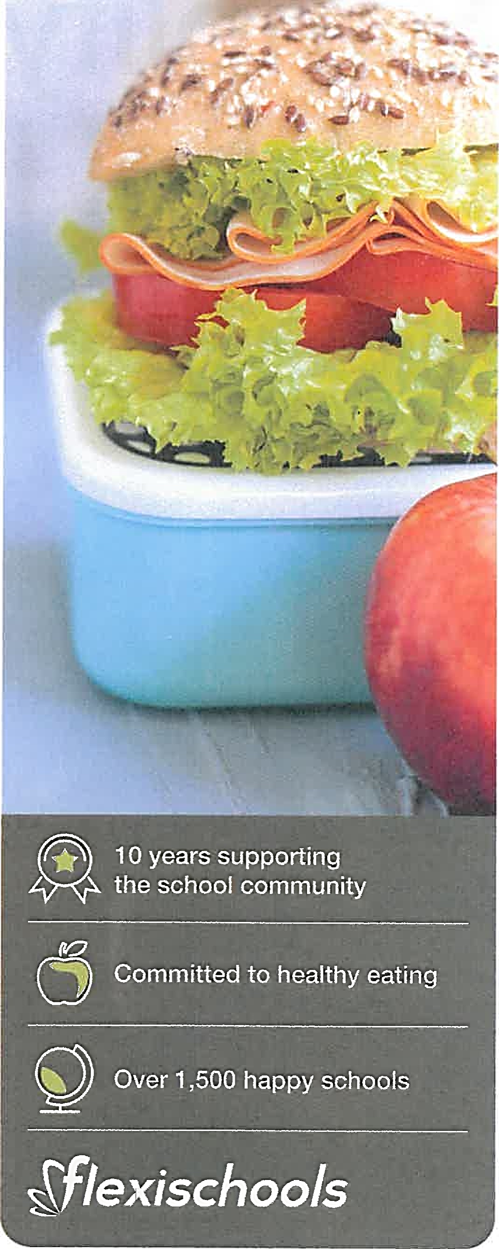
- Download the Flexischools App
Note: for iPhone and iPad please select 'Allow' notifications

- Login/Register

- Already a Flexischools user:
Enter your details and login.
To save your login details select ‘remember me'

- New Fiexischools user
Click 'Register', enter your email address and follow the instructions in the email to set up your account. Once your account is set up, add new student; search for their school, enter student details and select their class.
- Top Up Your Account
To make ordering fast and simple, you can set up automatic top ups in your 'User Profile'

Order
- Place your Order
On the app home screen, scroll down to view your school services such as canteen and uniforms. Then swipe left and right to view all available services.
- Make your Selection
Find the service and press 'Order', then select the items you wish to order.
- Make Payment
Select your payment option and complete payment to place your order.

The Flexischools service is provided by lnLoop Pty Ltd (ABN 27 114 508 771) (trading as FlexiSchools) which holds Australian Financial Services Number 471558. Any information provided is general only and does not take into account your objectives, financial situation or needs. Please read and consider the Combined Financial Services Guide and Product Disclosure Statement at www.flexischools.com.au before acquiring or using the service. For more information please visit www.flexischools.com.au

